Types of Firewall
# Source: AI Source: Provided by: [Data Path: Persons Table -> ID Column: 1, Name_En Column: Motasem Essam] -> From: [ChatGPT] on [12/18/2025]
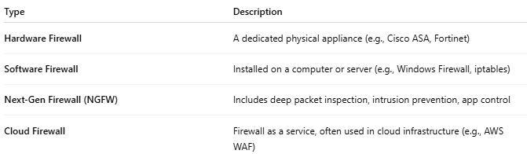

Type | Description
Hardware Firewall | A dedicated physical appliance (e.g., Cisco ASA, Fortinet)
Software Firewall | Installed on a computer or server (e.g., Windows Firewall, iptables)
Next-Gen Firewall (NGFW) | Includes deep packet inspection, intrusion prevention, app control
Cloud Firewall | Firewall as a service, often used in cloud infrastructure (e.g., AWS WAF)

